**HUAWEI REVIEWER**

SINGLE CHOICE

1. The OpenFlow switch forwards packets based on a flow table, and each flow entry includes multiple parts. Which of the following fields in a flow entry is used to describe the processing mode after matching?

A. Match Fields  
B. Instructions  
C. Priority  
D. Cookie  
<https://support.huawei.com/enterprise/en/doc/EDOC1100198822/c824b277/openflow-working-mechanism>   
<https://support.huawei.com/enterprise/en/doc/EDOC1100075344/c824b277/openflow-working-mechanism>

2. In network O&M. Telnet is one of the protocols used to connect to remote devices. Which of the following devices does not support remote connection through Telnet?

A.AR  
B.AC  
C.PC  
D. AP  
<https://support.huawei.com/enterprise/en/doc/DOC1000128405/95595f1/display-openflow-flows-standard>

3. Which of the following statements is false about CAPWAP tunnels? An engineer has configured wireless services on an AC as follows: Which of the following statements is false about the configuration?

[AC-wlan-view] security-profile name wian-net  
[AC-wlan-sec-prof-wlan-net] security wpa-wpa2 dotix acs  
[AC-wlan-sec-prof-wlan-net] quit  
[AC-wlan-view] ssid-profile name wlan-net  
[AC-wlan-said-prof-wlan-net] ssid wlan-net.  
[AC-wlan-ssid-prof-wlan-net] quit  
[AC-wlan-view] vap-profile name wlan-net.  
[AC-wlan-vap-prof-wlan-net] forward-mode direct-forward  
[AC-wian-vap-prof-wlan-net] service-vlan vlan-id 101  
[AC-wlan-vap-prof-wlan-net] security-profile wian-net  
[AC-wlan-vap-prof-wlan-net] suthentication-profile wlan-net  
[AC-wlan-vap-prof-wlan-net] ssid-profile wlan-net  
[AC-wlan-vap-prof-wlan-net] quit

A. The name of the configured wireless signal is wlan-net.  
B. 802.1X authentication is required for STAs to access the WLAN  
C. The STA data forwarding mode is tunnel forwarding.  
D. The service VLAN for STAs is VLAN 101

<https://support.huawei.com/enterprise/en/doc/EDOC1100198822/c824b277/openflow-working-mechanism>

4.Which of the following statements is false about CAPWAP tunnels?

A. CAPWAP control packets are used to forward user service data.  
B. The AC centrally manages and controls APs through CAPWAP tunnels.  
C. The first step for establishing a CAPWAP tunnel is to enable the AP to obtain an IP address.  
D. After the CAPWAP tunnel is established, the AP goes online successfully

<https://support.huawei.com/enterprise/en/doc/EDOC1100075344/c824b277/openflow-working-mechanism>

5. A customer requires that 802.1X authentication be used for STA access authentication on a WLAN. To meet this requirement, which of the following is the correct security policy configuration on the AC?

A. [HUAIWE-wan-view] security profile name p1   
 [HUAWEi-wlan-sec prof-p1] security wpa-wpa2 dot1x aes

B. [HUAWEI -wlan-view] security-profile-name p1  
 [HUAWEI-wlan-sec prof-p1] security wpa-wpa2 ppsk dot1x

C. [HUAWEI-wlan-view] security-profile name p1   
 [HUAWEI-wlan-sec-prof-p1] security wpa ppsk dot1x

D. [HUAWEI-wlan-view] security profile name p1   
 [HUAWEI-wlan-sec-prof-p1] security wpa psk dot1x aes

<https://support.huawei.com/enterprise/en/doc/EDOC1100198822/c824b277/openflow-working-mechanism>

<https://support.huawei.com/enterprise/en/doc/EDOC1100075344/c824b277/openflow-working-mechanism>

6.On the WLAN shown in the figure, STAs roam between ACs at Layer 3. The user data forwarding mode configured on the two ACs is direct forwarding, the gateways of the service VLANs are located on the two switches, and the home agent uses the default configuration. Which of the following statements is true about the data forwarding path for a STA to access the Internet after roaming?

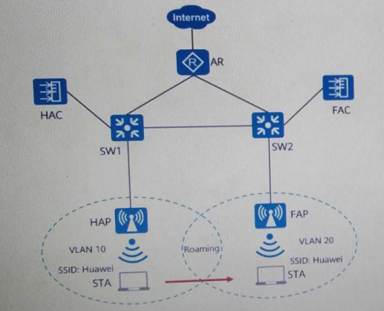

A. FAP-> FAC ->SW2 ->AR-> Internet

B. FAP ->FAC->HAC->HAP->SW1-> AR->Internet

C. FAP ->FAC->HAC-> SW1-> AR-> Internet

D. FAP ->SW2-> AR-> Internet

7. NAT translates the IP address in a packet header into another IP address. Which of the following is not an advantage of the NAT technology?

A. Saves IP address resources

B. Provides privacy protection for internal network users.

C. The address translation process is transparent to users.

D. Improves end-to-end communication efficiency

8. The SYN flood attack uses the TCP three-way handshake mechanism to attack the target computer. Which of the following statements is false about the SYN flood attack defense technology of Huawei firewalls?

A .Limiting the number of half-open TCP connections can defend against SYN flood attacks.

B. When the number of SYN packets to the same destination in a specific period exceeds the preset threshold, source authentication can be enabled to defend against SYN flood attacks.

C. To defend against different types of DoS attacks, different defense methods, such as source authentication and traffic limiting, are provided

D. Interzone security policies can be configured to defend against SYN flood attacks.

9. Gratuitous ARP packets are special ARP packets. When a host connects to a network, the host broadcasts a gratuitous ARP packet to check whether any device on the network uses the same IP address as its own IP address in the broadcast domain. Which of the following statements is false about gratuitous ARP?

A. Gratuitous ARP packets are ARP request packets,

8. Gratuitous ARP packets are unicast packets

CAttackers can use forged gratuitous ARP packets to launch man in the middle attacks,

D. Gratuitous ARP packets can be sent to check whether an IP address conflict occurs